Ecommerce Data Analysis
Project Overview
This project analyzes ecommerce sales using data from 3,06,000 customers across various locations, age and gender levels.
The goal is to uncover insights related to location, category, sub category, Brand, Payment mode, Delivery status, Final amount, Rating, Review Title, Sentiment, Customer Segment, Gender, Age Group and Complaint Raised to support strategic Sales decisions.

Dataset Summary
- Rows: 3,06,000
- Columns: 33
- Key Features Include:
  - Customers Demographics: Gender, Age, Location, Customer Segment
  - Product Details: Category, Sub Category, Brand, Delivery Status, Payment Mode, Final amount, Rating, Discount
  - Customer behavior Details: Review Title, Sentiment, Customer Segment, Complaint Raised

Exploratory Data Analysis (EDA) using Python
We began with data preparation and cleaning in Python.
1. Data Loading
- Imported the dataset using pandas.
2. Initial Exploration
- Used df.info() to inspect data structure.
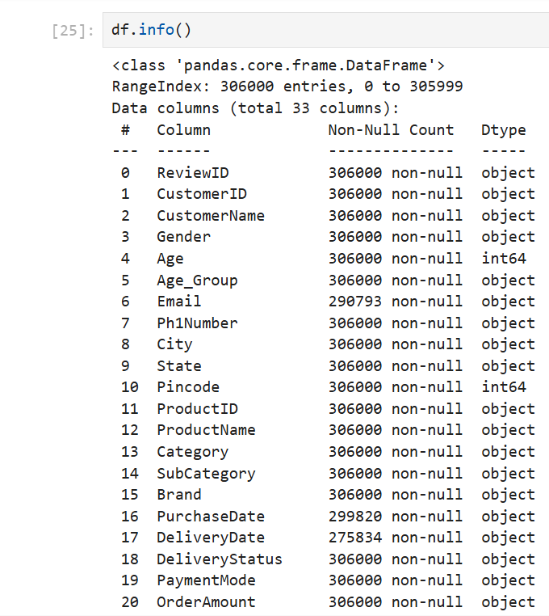

- Used df.describe() for summary statistics.
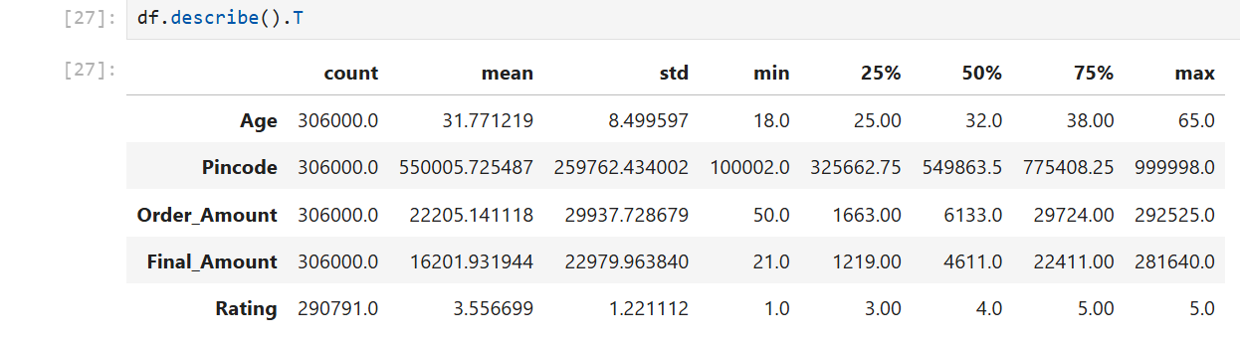

3. Missing Data Handling
- Checked for null values.
- Imputed missing values in Discount, Rating, Complaint Raised, Purchase Year, Purchase Month, Delivery Year, Delivery Month using the mean and mode of each column.
4. Dropping Irrelevant Columns
- Removed columns not needed for analysis.
5. Data Type Corrections
- Converted columns to appropriate data types for analysis and visualization purposes.

Data Analysis using SQL
We performed structured analysis in SQL to answer key business questions:
- Total Customers & Revenue by Gender & Age Group:
Gender and Age Group wise total customers and revenue.
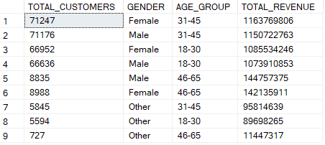

- Total Customers & Revenue by City & State:
City and State wise total customers and revenue.
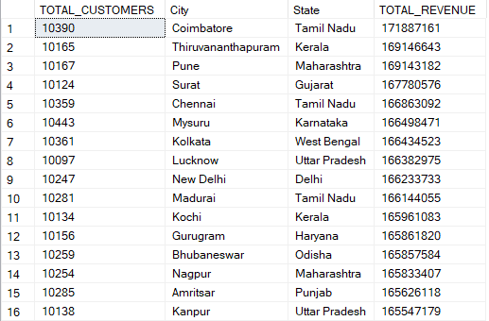

- Maximum Revenue & Average Rating by Category:
Category wise maximum revenue and average rating.
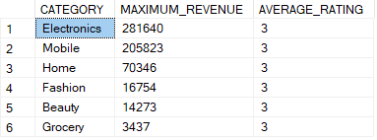

- Total Customers by Gender, Age Group, City, State:
Number of customers by Gender, Age Group, City, State those who cancelled the orders.
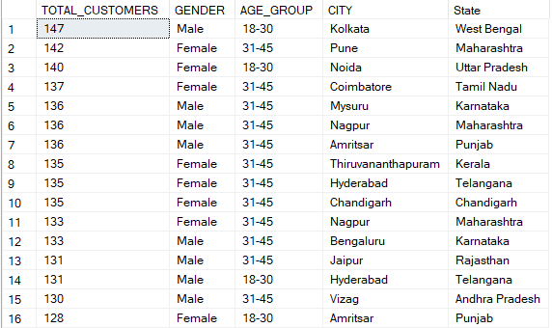

- Total Customers by City, Category, Brand:
Number of customers by City, Category, Brand those who returned the orders.
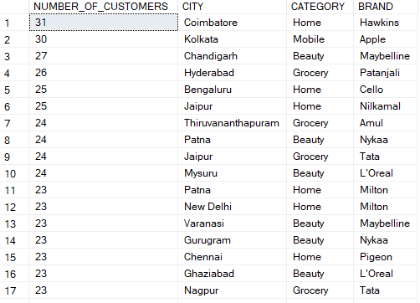

- Total Customers & Revenue & Rating by City, Category, Brand:
Number of customers, revenue and rating by City, Category, Brand those who pay via UPI.
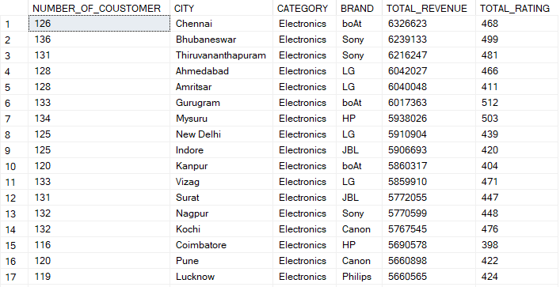

- Total Customers & Revenue & Rating by City, Category, Brand:
Number of customers, rating and revenue by City, Category, Brand those who pay via COD.
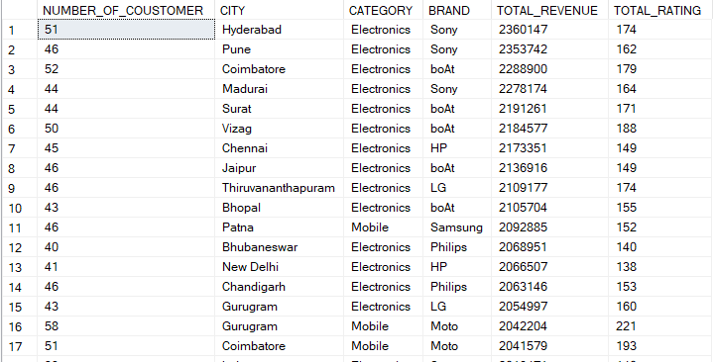

- Total Customers & Rating by Category, Brand, Review title:
Number of customers and rating by Category, Brand, Review title those who’s sentiment is Negative.
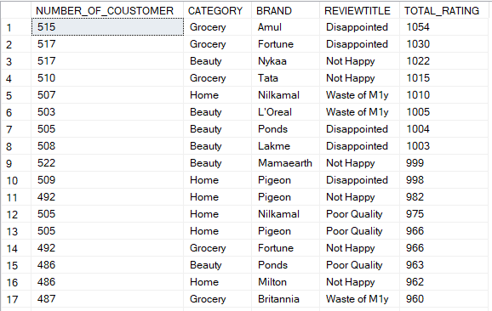

- Total Customers & Rating by Category, Brand, Review title:
Number of customers and rating by Category, Brand, Review title those who’s sentiment is Positive.
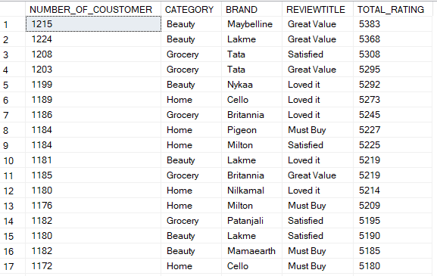

- Total Customers & Revenue by Gender, Age Group, Customer segment:
Number of customers and revenue by Gender, Age Group, Customer segment.
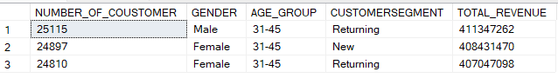
- Total Customers & Rating by Gender, Age Group, Customer segment:
Number of customers and rating by Gender, Age Group, Customer segment.
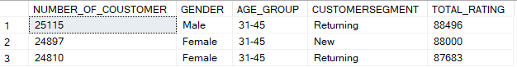

- Total Customers & Revenue & Rating by Category, Brand, Customer segment:
Number of customers, revenue and rating by Category, Brand, Customer segment.
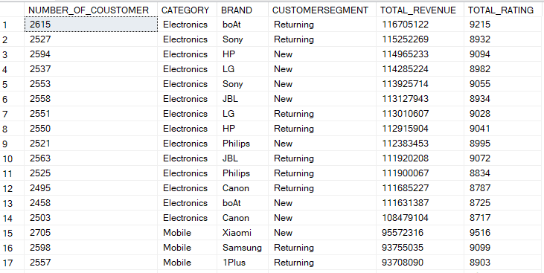

- Total Customers & Revenue & Rating by Category, Brand, Customer segment:
Number of customers, revenue and rating by Category, Brand, Customer segment those who raised complaint.
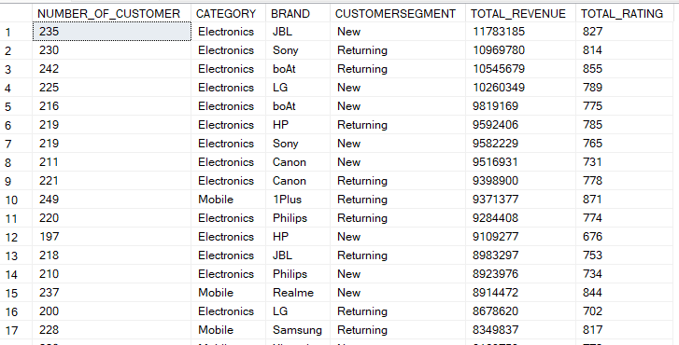

Dashboard Created Using Excel
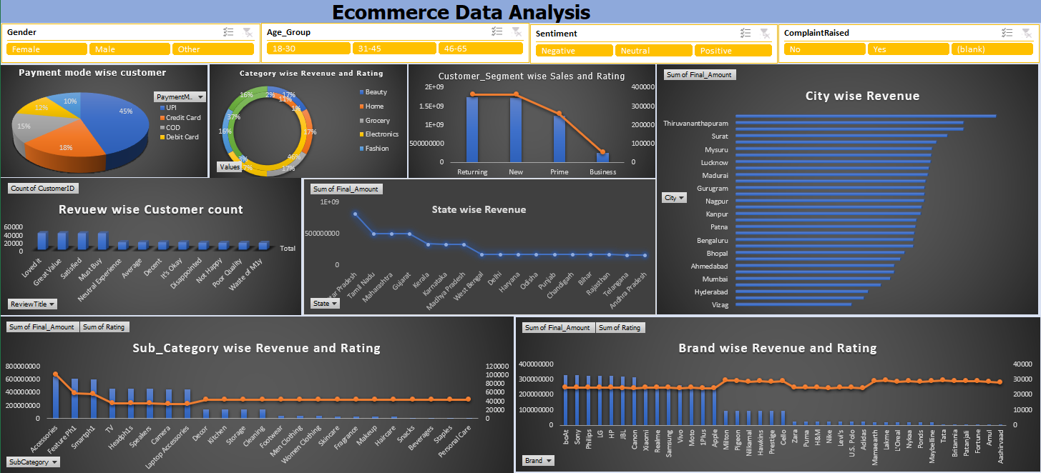

This Excel-based project focuses on analyzing key performance metrics from an E-Commerce dataset to uncover trends in customer behavior, sales performance, product categories, discounts, and ratings. Using Excel functions, pivot tables, charts, and data cleaning techniques, the analysis highlights patterns such as top-selling categories, customer segmentation and overall sales contribution by different product groups.
The insights derived from this project support data-driven decision making in areas like pricing strategy, product inventory planning, and customer satisfaction improvement.
Dashboard Created Using Tableau
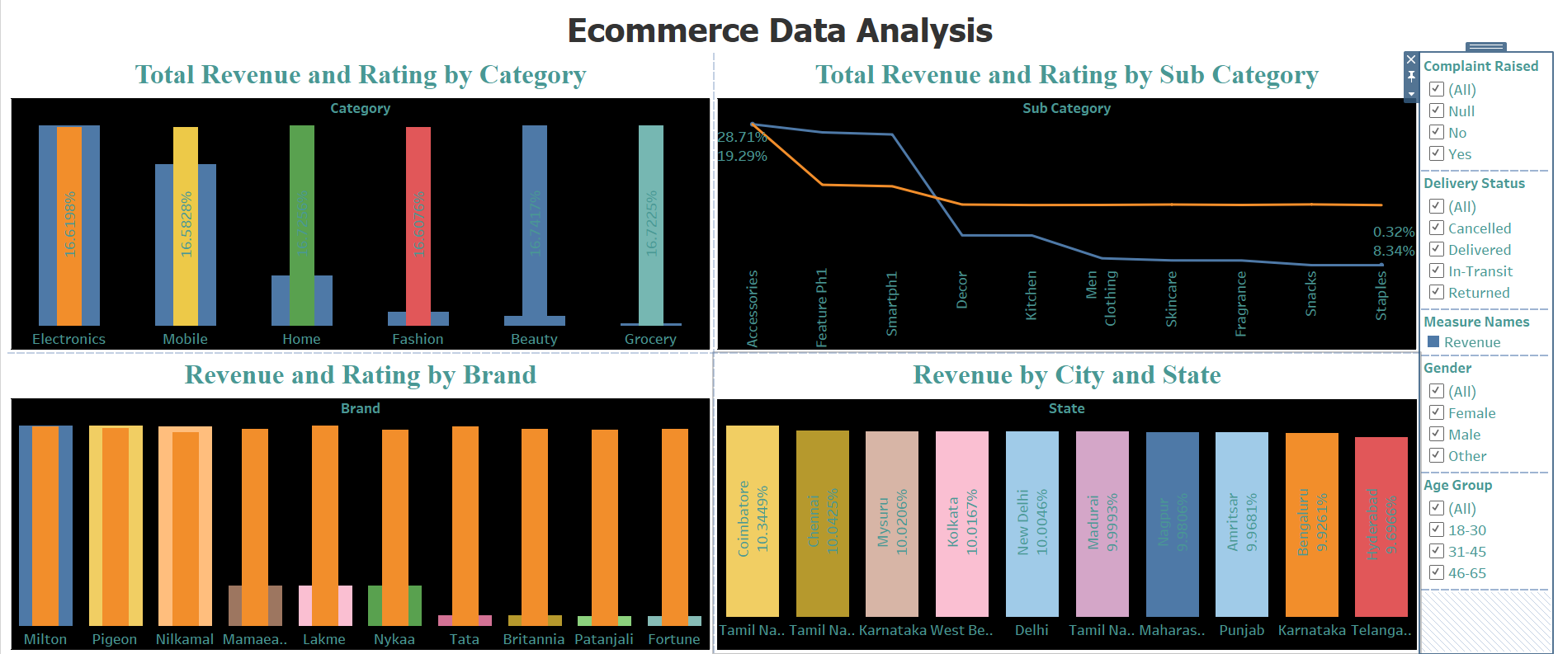
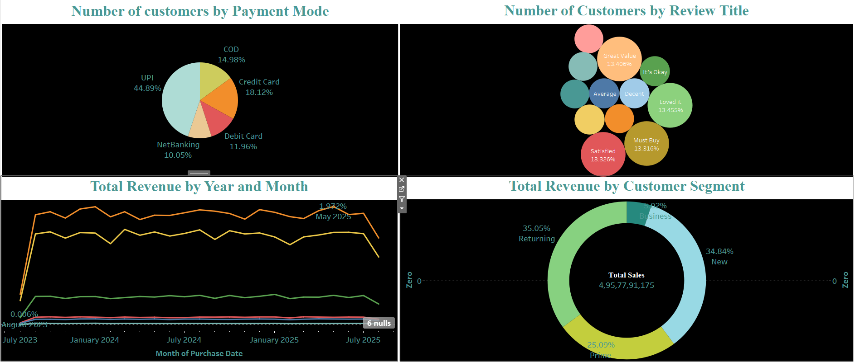

This Tableau project provides an interactive analysis of key e-commerce metrics, enabling users to explore customer behavior, sales performance, product trends. The dashboards incorporate dynamic filters to highlight top-performing categories, revenue distribution, customer segments.
The visualization offers a clear, insightful, and user-friendly interface to support data-driven decision-making in marketing strategy, product planning, and customer satisfaction improvement.

